Intensity of atmospheric motions in the mabl retrieved from ocean surface radar imagery

M. Mityagina

E-mail: mityag@iki.rssi.ru

Abstract. The paper is dedicated to the theory and practice of analysis of radar images of sea surface, obtained under unstable atmospheres. In this case, the sea surface reveals wind field variations in the marine atmospheric boundary layer (MABL) caused by atmospheric convec-tive processes, accompanied by air motions with mainly vertical direction. Changes in radar manifestations of convection signatures are connected with the degree of thermodynamic instability of the atmosphere.

1. Instruments used

The Almaz-1 SAR is an S-band radar (wavelength of 9.6cm) working at horizontal (HH) polarization and illuminating a swath of 40 x 240 km with a spatial resolution of (10-15) m.
The airborne radar is a Ku-band (wavelength of 2.25cm) instrument. Two cylindrical antennas, one on each side of the aircraft, transmit and receive alternate pulses of horizontal and vertical polari-zation at large incidence angles of (72 - 84)° to produce simultaneous HH and VV images. The radar illuminates a swath of 12.5 km on each side of the ground track with a spatial resolution of about 25 x 25 meters.
Besides, images from ERS 2 SAR are also used. The main cha-racteristics ERS SAR are: spatial resolution: along track <= 30 m; across-track <= 26.3 m; swath width: 102.5 km; incidence angle was 23 deg.
2. Area of Experiment and Preliminary Data Analysis
Results are based on the analysis of a series of experiments conducted in North Pacific in 1981, 1985 and 1987 (August-September) as well as during the Joint US/Russia Experiment in 1992 (July) when radar measurements of convection processes were made. Radar images obtained over Black Sea in (1999 - 2003) are also considered. The analysis involved meteorological parameters measured in situ over the corresponding period.
Extensive analysis of numerous images recorded under stable, unstable and neutral MABL conditions shows that cell-formed or cylinder-formed textures in VV radar images are distinctly visible every time when the sea surface is warmer than the near surface air. These patterns are connected with the origin and the development of atmospheric convection resulted from unstable stratification in the ocean-atmosphere boundary layer.
Typical dimensions of convective structures in the plane of observation are (500–600) m for the Pacific test region and (800-1000) m for the North-Atlantic. Approximately 70% of the images bearing surface imprints of MABL cell convection were obtained in the absence of clouds. The regular spatial structures seen in the images effectively preceded the formation of convective clouds.

3. Influence of boundary layer stability on the radar return formation

Perhaps the most striking aspect of Ku-band imagery is extreme sensitivity of the vertical-polarization clutter characteristics to the atmospheric stability [1,2]. Under stable atmospheric conditions, when the air temperature is greater than the surface one, the vertical polarization images are qualitatively similar to those recorded at horizontal polarization. But under unstable atmospheres the situation is quite opposite. Near-surface wind variations induced by intensive convection in the boundary layer produce high contrast cellular pattern in the VV images, while HH-polarized one is not disturbed. The given in fig.1 radar images obtained in July 1992 illustrate this fact.
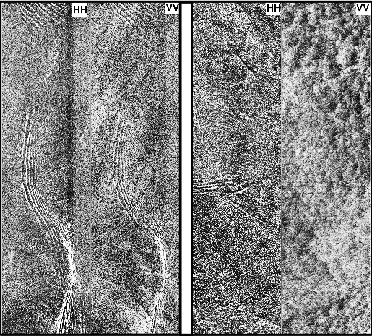
These phenomena are observed in radar images recorded over a number of years of experiments in the North-West Pacific, near the Kamchatka peninsula. An extension of analysis of numerous images recorded under stable, unstable and neutral atmospheric boundary layer conditions shows that cellular-type structures in VV radar images are distinctively visible every time when the sea surface is warmer than the near surface air and are never detected under other conditions. It means that an analysis of Ku-band radar images at vertical polarization makes it possible to determine the type of the boundary layer stratification and radar images clutter patterns at vertical polarization are to be regarded as an indicator of boundary layer conditions. Cellular or roll structures in the VV images were observed throughout the experiments whenever the sea surface was warmer then the near surface air and was never detected under other conditions.
a b
Figure 1. Double polirazed (VV-HH) radar images of sea surface ob- tained under a) stable (a) and unstable (b) atmosphere boundary layer conditions on.

4. Modeling

The results of field experiment were considered and compared with theory. For the interpretation of experimental data a model presented in [3] was used. This model is based on a meteorological version of the Boussinesq equations for the thermal convection [4]. The model introduces an atmospheric Rayleigh number for dry convection, where the thermal conductivity k and the molecular viscosity ν are replaced by their eddy counterparts ( k _{e} and ν_{e} correspondingly). This type of formulation is extended also for moist convection. The mathematical model treated is one in which a layer of Boussinesqu fluid between two conducting porous boundaries is given a uniform vertical velocity.

5. Implications of theory and experiment comparisons

Fig.2 features a set of vertical polarization radar images of sea surface obtained in August 1985 over the North Pacific near the Kamchatka peninsula. The images contain imprints of various convective patterns.
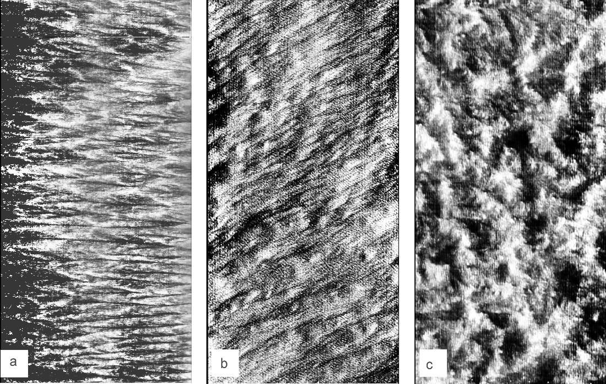
Figure 2. Ku-band RAR images featuring different regimes of atmospheric convection. Images are registered in North-Western Pacific near Kamchatka peninsula:
- convective rolls, ΔT = - 0.4°, wind speed 6 m/c;
b) convective rolls and cells, ΔT = - 1.5°, wind speed 7.5 m/c;
- convective cells, ΔT = - 6.5°, wind speed 6 m/c.

Convection processes caused by weak thermodynamical instability of atmosphere and by small rate of cooling of sea surface occur as cylinder-formed flow. Radar signatures of convective flows under linear temperature profile and weak instability should cause the appearance of alternating bands of weak and strong backscattering. Fig. 2a illustrates this situation.
When the atmospheric instability becomes stronger, the cylinder structure of flows is changed into a cell structure. This situation is shown in Fig.2b.
A system of well-developed convective cells exists under conditions of strong atmospheric instability. These cells can be seen in Fig. 2c.
We conclude that radar backscattering from ocean surface can supply information about vertical motion and energy exchange in ABL. While cylinder-formed structures are quite visible in radar images, vertical motions and energy exchange in ABL are expressed rather weakly. On the other hand, cellular clutter patterns can be regarded as an indicator of prominent vertical motions in the boundary layer, with their horizontal sizes growing with the increase of the temperature difference ( T_{water} - T_{atm} ).

Cell convection spatial spectra

A remarkable feature of convection in rotating inhomogeneous atmosphere is that it can generate eddies. This may lead to a significant change in the instability character and a transformation of the convective system [5]. In other words, energy redistribution is very likely along with the increase of the wind speed horizontal component due to the impact of turbulent heat influx. Coherent structures may also appear. We have computed two-dimensional spatial Fourier spectra of radar images containing distinct convective cells. Convective cell sizes are from a few hundred meters to several kilometres.
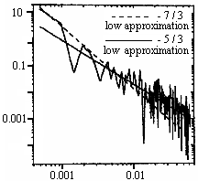
Figure 3. Spectral density integrated over a narrow angle interval
around the selected azimuth angle.

Anisotropy of two-dimensional spectra of scales greater than convec-tive cell sizes is of particular interest. Analysis of one-dimensional cross-sections for various directions has revealed the existence of two regions characterized by different degrees of spectral density decrease. In the region of scales less than convective cell dimensions, a prac-tically isotropic Kolmogorov spectrum ( Е(к) ~ 1 / к ^{5/3} ) is observed, while in the region of larger scales, spectral density along particular directions decreases according to some power law as well, but with another power index. Spectral density, integrated over a narrow angle interval around the selected azimuth angle corresponding to the given direction, decreases under a power law with an index close to – 7 / 3. An example of the spectrum is given in Fig. 2.
In this case, large-scale coherent structures in the form of convective motion amplification and abatement bands perpendicular to these particular directions are observed in radar images. In the cases we considered, establishment of spectral density 1 / k ^{7/3} is observed in a spatial scale interval of 1.5 to 15 km. This may be viewed as an experimental evidence of formation of a region of cascade spirality transfer over the spectrum in this interval. Theoretical issues of this phenomenon are discussed in the paper of Prof. S. S. Moiseev [6].

References.

1. R.Romeiser. On the polarization-dependent signatures of atomsphe-
ric and oceanic features in radar images of the ocean surface, Proc.
Intern. Geoscience and Remote sensing Simposium (IGARSS'97),
Inst.of Elec.and Electr.Eng., Piscataway, N.J., USA, 1997, p.1326.
2. M.I.Mityagina, V.G.Pungin, V.V.Yakovlev.//Waves in Random
Media, 1998, v. 8, p.111.
3. R.Krishnamurti. //J.Atmos. Sci.,1975, v. 33, p.1353.
4. E.M.Agee, T.S.Chen.// Jour.Atmos. Sci., 1973, v.30, p.180.
5. S.S.Moiseev, P.B.Rutkevich, А.V.Tur, V.V.Yanovsky, // JETP,
1988, v.94, № 2, p.144.
6. S.S.Moiseev, O.G.Chkhetiany.//JETP, 1996, v.110, № 1, p.357.

