Route descriptions

Metro station Kaluzhskaya – IKI

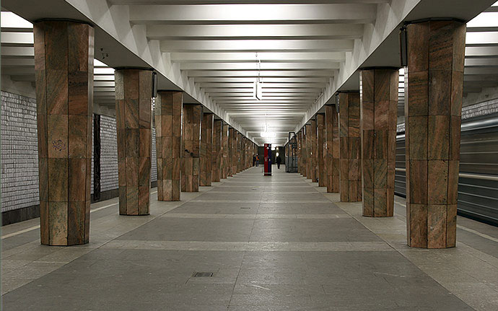
You should get off at "Kaluzhskaya" subway station using the southern exit. If you are going from the city center this exit will be in the direction of your travel (to the head of a train). After you got out the train doors, turn right and proceed to the escalator (moving staircases) in the direction of your train movement. Use the escalator to go upstairs. After leaving the station lobby through glass doors you should go STRAIGHT to the end of the tunnel (to the fast food kiosk), then take RIGHT and use the stairs to get to the surface. Here you should turn RIGHT and go about 150 meters along the highway (Obrucheva St) to the white and black iron fence with pink concrete base surrounding parking place. Here you turn LEFT and take a narrow path along this fence to the IKI building.
